DAY 18 –LECTURE NOTE
Monday, September 30th, 2019.

INTRODUCTION
Node.js (or NodeJS) is an open-source, cross-platform, JavaScript run-time environment that executes JavaScript code without a web browser. In other words, it is an interpreter that can be used to run JavaScript programs instead of using the traditional web browser console (F12). Node.js was developed by Ryan Dahl in 2009.

FEATURES
Node.js also includes new JavaScript syntax and built-in APIs (called Modules) for server-side scripting. Server-side scripting refers to programming the “backend” processes of a web application known as the Business Logic. Basic features of Node.js include;
- Dynamic Webpages – Generate webpage content based on predefined parameters. Eg. Dashboard.
- Data Validation – Validate user input as a form is being filled or after the form is submitted.
- File System – Create, Read, Update, Delete and Rename files on a server.
- Database Comm. – Interact with Database Management Systems such as MySQL and MongoDB.

GET STARTED
- Download and install Node.js (https://nodejs.org/dist/v10.16.3/node-v10.16.3-x86.msi).
- The installation process will pre-install two programs; Node.js and Node.js Command Prompt.
- After installation, a setup folder will be created in the following directory; C:\Program Files (x86)\nodejs\*.
- Click on Windows Start button and type “Node.js”.
- Select “Node.js Command Prompt” from the search results. The terminal window below should launch and the name of your computer will be displayed instead of “bfv”. C:\Users\bfv\* is referred to as Node.js Default Directory.
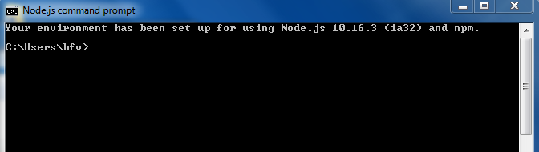
- Test Node.js server connection. Type the code snippet below into a text-editor and save the file to the Node.js Default Directory in STEP 5 above.

Ex 1. File: ping.js
// TODO test NodeJS server connection
console.log(“Hello, World!”);

- Execute the ping.js program. Type the query string “node filename” to execute JavaScript programs using Node.js Command Prompt.
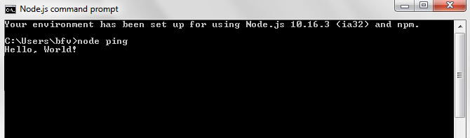
- Congrats, you have successfully created and executed a JavaScript program using Node.js.

EXERCISE
Create the two files below using a text-editor, and save them to Node.js Default Directory:

Ex 2. File: 47_scores_main.js
// TODO read and buffer JSON file using NodeJS
const stream = require('fs'); // import file system api/module
// INPUT
var directory = './47_scores_data.json'; // declare the file to read
// PROCESS
stream.readFile(directory,buffer); // invoke method to read file and buffer file content
function buffer (error, data)
{
if (error) throw error; // exception handling
let record = JSON.parse(data); // convert file content to record
let regno = "", score = "", grade = "", remarks = "";
let row = {}, field = {}, collection = [];
for (let i in record)
{
// declare each array element as row
row = record[i];
// read each row property
regno = row.regno;
score = parseInt(row.score); // convert to number
// compute grade and remarks based on score
if (score >= 80) {grade = "A"; remarks = "Distinction";}
else if (score >=60 && score < 80) {grade = "B"; remarks = "Excellent";}
else if (score >=40 && score < 60) {grade = "C"; remarks = "Good";}
else if (score >=20 && score < 40) {grade = "D"; remarks = "Fair";}
else {grade = "F"; remarks = "Poor";}
// create empty field record
field = {};
// initialize field record
field.Registraion_Number = regno;
field.Score = score;
field.Grade = grade;
field.Remarks = remarks;
// append each field to collection
collection[i] = field;
}
// OUTPUT
console.table(collection); // display as table
}

Ex 3. File: 47_scores_data.json
// TODO database table of student scores
[
{
"regno": "HWP/RMSC/001",
"score": "10"
},
{
"regno": "HWP/RMSC/002",
"score": "20"
},
{
"regno": "HWP/RMSC/003",
"score": "30"
},
{
"regno": "HWP/RMSC/004",
"score": "40"
},
{
"regno": "HWP/RMSC/005",
"score": "50"
},
{
"regno": "HWP/RMSC/006",
"score": "60"
},
{
"regno": "HWP/RMSC/007",
"score": "70"
},
{
"regno": "HWP/RMSC/008",
"score": "80"
},
{
"regno": "HWP/RMSC/009",
"score": "90"
},
{
"regno": "HWP/RMSC/010",
"score": "100"
}
]

The output of the exercise above is shown below;
